 **GO-STANDARD NURSERY & PRI-SCHOOL**

**END OF YEAR EXAMINATION 2023**

**END OF TERM III EXAMINATION 2023**

**PRIMARY THREE**

**LITERACY 1B**

**A**

**B**

**For Examiner’s**

**use only**

**TOTAL**

***Time Allowed: 2hours 15 minutes***

**Name: ______________________________________________**

**School: _____________________________________________**

**Class: ___________________________________________**

**SECTION A**

1. Name any **one** leader in your community.

________________________________________________________________________

1. Name the direction in which the sun rises. ________________________________________________________________________
2. What is child abuse?

________________________________________________________________________

1. How are Nimbus clouds useful to farmers.

________________________________________________________________________

1. **Draw and name one craft used at home.**

|  |
| --- |
|  |
|  |

1. Why do people keep birds at home?

________________________________________________________________________

1. Give **one** leader found at home.

________________________________________________________________________

1. How is a school important in our community?

________________________________________________________________________

1. Mention any **one** basic need of children.

________________________________________________________________________

1. **Name this material found in a classroom.**

_________________________________________________________

1. State any **one** role of a father at home.

________________________________________________________________________

1. Give the importance of social activities in our community.

________________________________________________________________________

1. 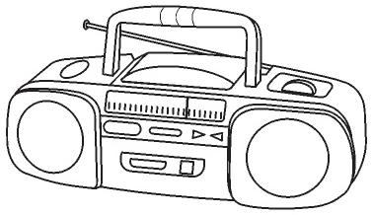**How is the item below useful at home?**

__________________________________________________________

1. State any **one** right of children.

________________________________________________________________________

1. Give **one** means of road transport.

________________________________________________________________________

1. How do children promote peace at school?

________________________________________________________________________

1. Name **one** recreation activity done at home.

________________________________________________________________________

1. Write **one** type of family you know.

________________________________________________________________________

1. Give any **one** cardinal point of a compass.

________________________________________________________________________

1. What is an economic activity?

________________________________________________________________________

1. Name **one** social service provided by doctors.

________________________________________________________________________

1. Write **UWEC** in full.

________________________________________________________________________

1. How is dressing an important cultural practice?

________________________________________________________________________

1. Give any **one** indicator of peace among people in a society.

________________________________________________________________________

1. Why do we need leaders in our community?

________________________________________________________________________

1. Mention any **one** cultural practice among the Baganda.

________________________________________________________________________

1. 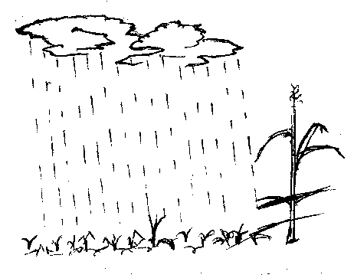**Name the type of weather drawn below.**

________________________________________________________

1. Why do children need holidays?

________________________________________________________________________

1. Name **one** group of people that work in a school.

________________________________________________________________________

1. Mention the school symbol that directs people to a school.

________________________________________________________________________

1. Name **one** thing found in a good home.

________________________________________________________________________

1. How do people meet their needs in our community?

________________________________________________________________________

1. Give any **one** example of a temporary house.

________________________________________________________________________

1. 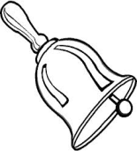How is the item drawn below useful at school?

________________________________________________________

1. Give any **one**  element of a good map.

________________________________________________________________________

1. State one example of a class rule in your class.

_________________________________________________________________________

1. Where do sick pupils go for treatment?

________________________________________________________________________

1. Write one example of school property.

________________________________________________________________________

1. Give one term used to mean things that surround man.

_________________________________________________________________________

1. Mention one example of a cardinal point.

_________________________________________________________________________

**SECTION B**

1. a) What is a resource? _________________________________________________

_____________________________________________________________________

b) Give any **two** examples of resources in the environment.

i) ______________________________ ii) _______________________________

c) How is water useful at home?

____________________________________________________________________

1. a) Mention any **two** things found in a good house.

i) ________________________________ ii) ________________________________

b) How do parents take care of their children?

____________________________________________________________________

c) Why do people build fences around their homes?

_____________________________________________________________________

1. a) Name any **two** animals kept in the zoo.

i) ________________________________ ii) ________________________________

b) Why do people keep animals at home?

____________________________________________________________________

c) State **one** way of caring for animals.

_____________________________________________________________________

1. a) What is the role of the police in a community?

_____________________________________________________________________

b) Apart from the police, give any other **two** groups of people who keep security in our community.

i) ________________________________ ii) ________________________________

c) How do we keep security at school?

____________________________________________________________________

|  |  |
| --- | --- |
| **C:\Program Files\Microsoft Office\CLIPART\PUB60COR\J0101980.WMFC:\Program Files\Microsoft Office\CLIPART\PUB60COR\J0101980.WMFC:\Program Files\Microsoft Office\CLIPART\PUB60COR\J0101980.WMFA** | **https://encrypted-tbn1.gstatic.com/images?q=tbn:ANd9GcQ4luQBdhroBjy5XjHJfye5ahIaS3VcEVhcyBvCvz53zCsf__VQ0wdownload (4)B** |

a) Name the projects marked with letters **A** and **B**.

**A** _________________________________ B_______________________________

b) Name **one** thing needed to start a project.

_____________________________________________________________________

c) Give **one** benefit of a project.

____________________________________________________________________

1. a) Name any **two** things made from local materials.

i) ________________________________ ii) ________________________________

b) How is a ball useful to children?

____________________________________________________________________

c) Why do people make crafts?

_____________________________________________________________________

1. a) Name the **two** seasons in a year.

i) ______________________________ ii) _______________________________

b) Give **one** activity done in the wet season.

_____________________________________________________________________

c) Why do people harvest crops in the dry season?

____________________________________________________________________

1. a) Mention any **two** things a school can get from its neighbours.

i) ________________________________ ii) ________________________________

b) Give **one** cause of problems between a school and its neighbours.

_____________________________________________________________________

c) How can a school prevent problems with its neighbours?

_____________________________________________________________________

1. a) State **two** activities done by children to help their parents.

i) _______________________________ ii) ________________________________

b) Why do children help their parents at home?

_____________________________________________________________________

c) **Draw and name one item used to clean a house.**

|  |
| --- |
|  |
|  |

1. a) What is transport? ___________________________________________________

_____________________________________________________________________

b) Give any **two** means of road transport.

i) _____________________________ ii) _________________________________

c) State any **one** unsafe way of using the road.

____________________________________________________________________

1. a) Mention any two elements of a good map.
2. ______________________________________________________________
3. _______________________________________________________________

b) Name the map symbols shown below.

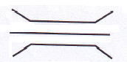

i) ____________________________________________________



ii) __________________________________________________

1. a) What is Communication?

___________________________________________________________________

b) Mention one example of a radio station you know.

____________________________________________________________________

c) Draw and name two means of communication.

|  |  |
| --- | --- |
|  |  |
|  |  |

1. a)Name the places where these leaders are found.
2. Head teacher _________________________________________________
3. Reverend _____________________________________________________

b) State any two qualities of a good leader.

i) ___________________________________________________________________

ii) __________________________________________________________________

1. a) Name any lake well know for salt mining in Uganda.

____________________________________________________________________

b) Why are fish mongers useful to our community?

____________________________________________________________________

1. a) What is a home stead?

____________________________________________________________________

b) Why do people build houses?

____________________________________________________________________

c) Draw and name two buildings materials for a permanent house.

|  |  |
| --- | --- |
|  |  |
|  |  |

**END**